**File Name: 3. spring-rest-handson**

**Problem Statement - Display Employee List and Edit Employee form using RESTful Web Service**

**Employee-config.xml**

<?xml version="1.0" encoding="UTF-8"?>

<beans xmlns="http://www.springframework.org/schema/beans"

xmlns:xsi="http://www.w3.org/2001/XMLSchema-instance"

xsi:schemaLocation="http://www.springframework.org/schema/beans

http://www.springframework.org/schema/beans/spring-beans.xsd">

<bean id="employee1" class="com.example.employeeservice.Employee">

<property name="id" value="1"/>

<property name="name" value="Joel"/>

<property name="department" value="HR"/>

</bean>

<bean id="employee2" class="com.example.employeeservice.Employee">

<property name="id" value="2"/>

<property name="name" value="Raja"/>

<property name="department" value="IT"/>

</bean>

<bean id="employee3" class="com.example.employeeservice.Employee">

<property name="id" value="3"/>

<property name="name" value="Athish"/>

<property name="department" value="Finance"/>

</bean>

<bean id="employeeList" class="java.util.ArrayList">

<constructor-arg>

<list>

<ref bean="employee1"/>

<ref bean="employee2"/>

<ref bean="employee3"/>

</list>

</constructor-arg>

</bean>

</beans>

**Employee.java**

package com.example.employeeservice;

public class Employee {

private int id;

private String name;

private String department;

public int getId() {

return id;

}

public void setId(int id) {

this.id = id;

}

public String getName() {

return name;

}

public void setName(String name) {

this.name = name;

}

public String getDepartment() {

return department;

}

public void setDepartment(String department) {

this.department = department;

}

}

**EmployeeController.java**

package com.example.employeeservice;

import com.example.employeeservice.Employee;

import org.springframework.context.ApplicationContext;

import org.springframework.context.support.ClassPathXmlApplicationContext;

import org.springframework.web.bind.annotation.*;

import java.util.List;

*@RestController*

*@RequestMapping*("/api/employees")

public class EmployeeController {

ApplicationContext context = new ClassPathXmlApplicationContext("employee-config.xml");

*@GetMapping*

public List<Employee> getAllEmployees() {

return (List<Employee>) context.getBean("employeeList");

}

*@GetMapping*("/{id}")

public Employee getEmployeeById(*@PathVariable* int id) {

List<Employee> employees = (List<Employee>) context.getBean("employeeList");

return employees.stream()

.filter(emp -> emp.getId() == id)

.findFirst()

.orElse(null);

}

}

**EmployeeserviceApplication.java**

package com.example.employeeservice;

import org.springframework.boot.SpringApplication;

import org.springframework.boot.autoconfigure.SpringBootApplication;

@SpringBootApplication

public class EmployeeserviceApplication {

public static void main(String[] args) {

SpringApplication.run(EmployeeserviceApplication.class, args);

}

}

**OUTPUT:**

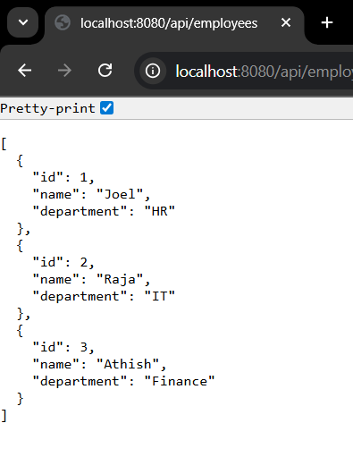

**Create static employee list data using spring xml configuration**

**Employee-config.java**

<?xml version="1.0" encoding="UTF-8"?>

<beans xmlns="http://www.springframework.org/schema/beans"

xmlns:xsi="http://www.w3.org/2001/XMLSchema-instance"

xsi:schemaLocation="http://www.springframework.org/schema/beans

http://www.springframework.org/schema/beans/spring-beans.xsd">

<!-- Department Beans -->

<bean id="hrDept" class="java.lang.String">

<constructor-arg value="HR"/>

</bean>

<bean id="itDept" class="java.lang.String">

<constructor-arg value="IT"/>

</bean>

<bean id="financeDept" class="java.lang.String">

<constructor-arg value="Finance"/>

</bean>

<!-- Reusable Skill Beans -->

<bean id="javaSkill" class="java.lang.String">

<constructor-arg value="Java"/>

</bean>

<bean id="angularSkill" class="java.lang.String">

<constructor-arg value="Angular"/>

</bean>

<!-- Employee Beans -->

<bean id="employee1" class="com.example.employeeservice.Employee">

<property name="id" value="1"/>

<property name="name" value="Joel"/>

<property name="department" ref="hrDept"/>

<property name="skills">

<list>

<ref bean="javaSkill"/>

</list>

</property>

</bean>

<bean id="employee2" class="com.example.employeeservice.Employee">

<property name="id" value="2"/>

<property name="name" value="Raja"/>

<property name="department" ref="itDept"/>

<property name="skills">

<list>

<ref bean="javaSkill"/>

<ref bean="angularSkill"/>

</list>

</property>

</bean>

<bean id="employee3" class="com.example.employeeservice.Employee">

<property name="id" value="3"/>

<property name="name" value="Athish"/>

<property name="department" ref="financeDept"/>

<property name="skills">

<list>

<ref bean="angularSkill"/>

</list>

</property>

</bean>

<bean id="employee4" class="com.example.employeeservice.Employee">

<property name="id" value="4"/>

<property name="name" value="David"/>

<property name="department" ref="itDept"/>

<property name="skills">

<list>

<ref bean="javaSkill"/>

</list>

</property>

</bean>

<!-- Employee List -->

<bean id="employeeList" class="java.util.ArrayList">

<constructor-arg>

<list>

<ref bean="employee1"/>

<ref bean="employee2"/>

<ref bean="employee3"/>

<ref bean="employee4"/>

</list>

</constructor-arg>

</bean>

</beans>

**Employee.java**

package com.example.employeeservice;

import java.util.List;

public class Employee {

private int id;

private String name;

private String department;

private List<String> skills;

public int getId() {

return id;

}

public void setId(int id) {

this.id = id;

}

public String getName() {

return name;

}

public void setName(String name) {

this.name = name;

}

public String getDepartment() {

return department;

}

public void setDepartment(String department) {

this.department = department;

}

public List<String> getSkills() {

return skills;

}

public void setSkills(List<String> skills) {

this.skills = skills;

}

}

**EmployeeDao.java**

package com.example.employeeservice;

import org.springframework.context.ApplicationContext;

import org.springframework.context.support.ClassPathXmlApplicationContext;

import java.util.ArrayList;

import java.util.List;

public class EmployeeDao {

public static List<Employee> *EMPLOYEE_LIST*;

public EmployeeDao() {

ApplicationContext context = new ClassPathXmlApplicationContext("employee-config.xml");

*EMPLOYEE_LIST* = (ArrayList<Employee>) context.getBean("employeeList");

}

public List<Employee> getAllEmployees() {

return *EMPLOYEE_LIST*;

}

}

**OUTPUT:**

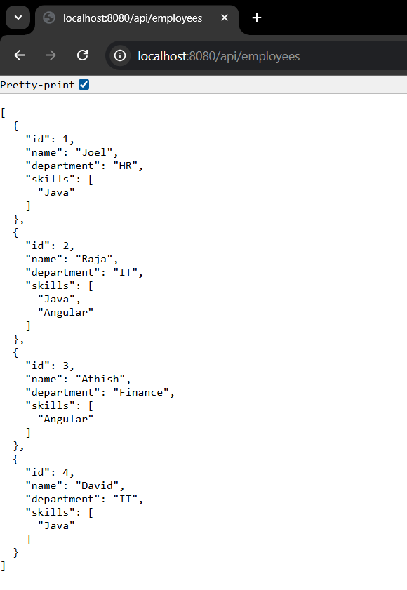

**Create static employee list data using spring xml configuration**

**EmployeeService.java**

package com.example.employeeservice;

import org.springframework.stereotype.Service;

import org.springframework.transaction.annotation.Transactional;

import java.util.List;

*@Service*

public class EmployeeService {

private final EmployeeDao employeeDao;

public EmployeeService() {

employeeDao = new EmployeeDao();

}

*@Transactional*

public List<Employee> getAllEmployees() {

return employeeDao.getAllEmployees();

}

}

**OUTPUT:**

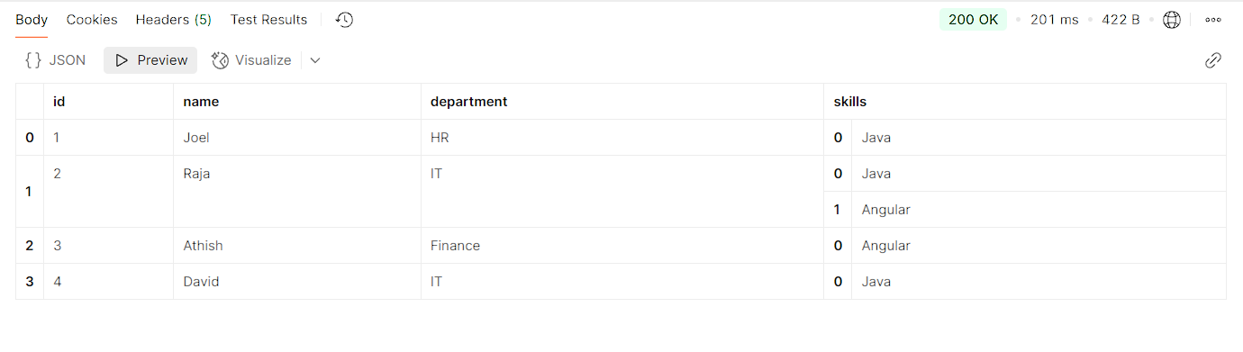

**Create REST service to gets all employees**

**EmployeeService.java**

package com.example.employeeservice;

import org.springframework.stereotype.Service;

import org.springframework.transaction.annotation.Transactional;

import java.util.List;

*@Service*

public class EmployeeService {

private final EmployeeDao employeeDao;

public EmployeeService() {

employeeDao = new EmployeeDao();

}

*@Transactional*

public List<Employee> getAllEmployees() {

return employeeDao.getAllEmployees();

}

}

**EmployeeController.java**

package com.example.employeeservice;

import org.springframework.beans.factory.annotation.Autowired;

import org.springframework.web.bind.annotation.GetMapping;

import org.springframework.web.bind.annotation.RestController;

import java.util.List;

*@RestController*

public class EmployeeController {

private final EmployeeService employeeService;

*@Autowired*

public EmployeeController(EmployeeService employeeService) {

this.employeeService = employeeService;

}

*@GetMapping*("/employees")

public List<Employee> getAllEmployees() {

return employeeService.getAllEmployees();

}

}

**OUTPUT:**

